DataModel - MOVIE

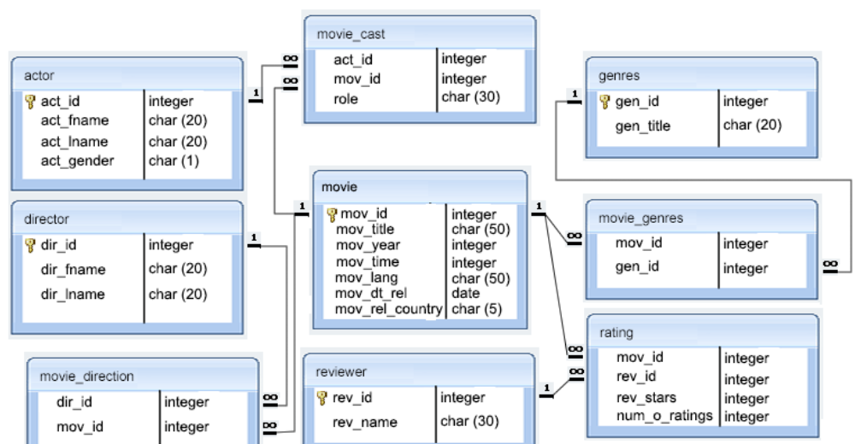

From above data model please write query to find –

1. Top 3 movies (based on average rating).
2. All the movies Directed by “Rajkumar Hirani”.
3. All the movies where “Boman Irani” acted as “Supporting Actor” role.
4. Find the directors & movie name who also acted on the same movie.
5. Find the name of director who created movie on all below 2 genre –
6. Thriller
7. Sci-Fi
8. Find the movie name & actor name where any Actor played role of multiple characters.
9. Find the actor nameswho played roles in maximum number of movies as “Leading Actor”. If more than one actor played maximum number of movies, then sort the result based on actor name.
10. Find how many Bengali movies releases outside India.
11. Which year maximum number of movies had been released.
12. Which director has maximum number of movies with 5-star rating.

---------Basic SQL query Using table : employees and quarterly_sales

1. Selecting All Columns From employees
2. Selecting Two Columns From employees
3. Selecting Two (or More) Columns From employees and Filtering Using Numeric Comparison in WHERE
4. Selecting Two Columns and Filtering from employees Using an Equality Condition in WHERE
5. Selecting Two Columns and Ordering by One Column from employees
6. Selecting Two Columns From employees and Ordering Descending by Two Columns
7. Selecting Two Columns With a Complex Logical Condition in WHERE from employees
8. Simple Computations on Columns from employees
9. Using SUM() and GROUP BY from employees
10. Using COUNT() and GROUP BY from employees
11. Using AVG() and GROUP BY from employees
12. Using MIN() and GROUP BY from employees
13. Using MAX() and GROUP BY from employees
14. Using SUM(), WHERE, and GROUP BY from employees
15. Using COUNT(), WHERE, and GROUP BY from employees
16. Accessing Data in employees and quarterly_sales Using INNER JOIN
17. Accessing Data in employees and quarterly_sales Using INNER JOIN and Filtering Using WHERE
18. Accessing Data in employees and quarterly_sales Using INNER JOIN, Filtering Using WHERE, and Sorting With ORDER BY